
Assessment Cover Sheet

Due Date
30-05-2026
Course Code
IT9204
Assessment Title
Project (Individual)
Course Title
Emerging Technologies in AI
Internal Moderator’s Name
Dr. Husain Naser
External Examiner’s Name

Not must-pass
Individual
Uncontrolled
Assessment Type

Learning Outcomes:
- CILO 1: Critically analyze emerging AI theories, paradigms,
- technologies, and their potential impact and limitations within
- evolving contexts.
- CILO 2: Evaluate advanced AI techniques to address complex
- challenges in diverse application domains, considering their ethical,
- societal, and economic implications.

Programme Title
Learner ID
202508958
Date Submitted

Learner Name
Master of Science in Artificial Intelligence
ICT9010 - MSc in Artificial Intelligence
Fatema Husain Hasan
Programme Code
Lecturer’s Name
Dr. Husain Naser

By submitting this assessment for marking, I affirm that this assessment is my own work.
Learner Signature

Do not write beyond this line. For assessor use only.
Assessor’s Name

Marking Date

Maks Obtained

Comments:

Table of Contents
Table of Figures 4
Table of Tables 4
Introduction 5
Background and Motivation 5
Problem Statement 5
Project Objectives 6
Scope and Limitations 6
Literature Review 7
Phishing Detection with Machine Learning 7
AutoML for Text Classification 7
Retrieval-Augmented Generation 8
LLM Agents and Tool Use 8
System Architecture 9
Architecture Overview 9
Azure Services 10
Component Interaction Flow 10
Part A: Data and Knowledge Layer (RAG) 11
Document Selection 11
RAG Pipeline 11
Part B: Machine Learning Component 13
Dataset 13
Data Preparation 14
Model Training: Manual Notebook 14
Model Training: Azure AutoML 15
Deployment 17
Part C: Agent System 18
Agent Design 18
Tools 18
Multi-Step Reasoning Example 18
Part D: Decision and Reasoning Layer 20
Routing Strategy 20
Decision Flow 20
Part E: System Integration 22
Part F: Evaluation and Analysis 24
Routing Evaluation Results 24
System Evaluation Results 24
Error Analysis and Failure Cases 26
RAG Retrieval Quality 26
Limitations 26
Proposed Improvements 26
Responsible AI and Ethical Considerations 27
Part I: Extra Challenging Work 28
Conclusion 29
Future Work 30
References 31
AI Disclosure 34
Project Resources 34

Table of Figures
Figure 1- System Architecture showing five integrated layers on Microsoft Azure 9
Figure 2 - RAG Retrieval Results 12
Figure 3 - Dataset Sample in Azure ML 13
Figure 4 - AutoML Best Model Run Metrics showing AUC weighted of 0.99683 15
Figure 5 - AutoML Models + Child Jobs showing all algorithms ranked by AUC weighted score 16
Figure 6 - Azure ML Managed Online Endpoint (phishing-online-endpoint) 17
Figure 7 - Agent detecting a phishing email - all three tools called in sequence (Path A routing) 19
Figure 8 - Agent responding to a guidance query - only retrieve_guidelines called (Path B routing) 19
Figure 9 - Decision and Routing Layer: Query Classification and Tool Dispatch 21
Figure 10 - Decision and Reasoning Layer - query routing flow across four paths 21
Figure 11 - System integration showing decision flow and routing of Q1 classification query 22
Figure 12 - System integration run showing agent response and results saved to JSON audit log 23
Figure 13 - Evaluation Results 25

Table of Tables
Table 1 - Azure Services Used in the System 10
Table 2 - RAG Document Knowledge Base 11
Table 3 - Phishing Email Dataset Statistics 13
Table 4 - Manual Model Performance Results 14
Table 5 - AutoML Experiment Configuration 15
Table 6 - AutoML Algorithm Comparison 16
Table 7 - ML Endpoint Deployment Properties 17
Table 8 - Agent Tools 18
Table 9 - Routing Evaluation Results 24
Table 10 - System Evaluation Test Cases 24
Table 11 - System Performance Summary 25
Table 12 - Responsible AI Implementation 27
Table 13 - Project Resources 34

Introduction

Background and Motivation
In the world of cybersecurity, phishing emails continue to be one of the most common risks organizations must deal with. Phishing continues to be the primary point of entry for most cybersecurity events, giving ransomware, data breaches, and financial fraud access to a system (Cybersecurity and Infrastructure Security Agency [CISA], 2024). Phishing remains a significant threat, accounting for more than 36% of data breaches in Verizon (2025)'s Data Breach Investigations Report. Moreover, as a cybersecurity employee this is a perfect topic for me to test my theories on.
However, traditional rule-based email filtering has serious limitations, including the failure to adapt to new phishing tactics and the restriction to employing static signatures. Additionally, they don't provide any context for the explanations or practical guidance, leaving users without the information necessary to make wise judgments. Basit et al. (2021) pointed out that while more email messages are being sent through legitimate cloud services and HTTPS, content-level AI analysis is becoming more important.
This project aims to overcome these challenges by developing and testing a Phishing Email Detection and Advisory Assistant (PEDAA), an intelligent AI-based system running on the cloud and integrating various AI technologies to deliver accurate, grounded, and context-aware responses. The system is based on the Retrieval-Augmented Generation paradigm proposed by Lewis et al. (2020), with agentic reasoning capabilities added as proposed by Yao et al. (2023) in ReAct.

Problem Statement
Three primary problems are meant to be resolved by this system:
- Detection: Use a trained machine learning model on Azure ML to classify emails as safe or phishing.
- Explanation: A thorough, approachable explanation of phishing flags based on reputable cybersecurity sources.
- Guidance: Giving the user precise, policy-based advice on how to address the problem they have detected.
One method cannot solve all three dimensions. Gao et al. (2024) demonstrated in their survey of RAG systems that adding retrieved documents to the LLM's output can significantly reduce hallucinations and increase factual accuracy, underscoring the need for RAG in use cases such as security advisory, where incorrect advice can cause harm.

Project Objectives
- Develop a Phishing Email Classifier using Azure Machine Learning and AutoML with high accuracy and AUC-ROC on Kaggle Phishing Email dataset.
- To support system answers with reliable cybersecurity papers, use a Retrieval-Augmented Generation (RAG) pipeline using Azure AI Search and text-embedding-3-small.
- Using the ReACT reasoning framework, create and implement an AI agent using Azure AI Foundry, GPT-4o, and function calling (Yao et al., 2023).
- To choose the combination of tools to use for a particular question, include a clear decision-making and reasoning stage.
- Put all the components together to create an end-to-end system, then evaluate its performance in several ways.
- To illustrate more challenging tasks, sophisticated RAG techniques like Hybrid BM25 + vector search with CrossEncoder reranking are used.
- Examine system performance, constraints, and responsible AI factors in accordance with Microsoft's Responsible AI guidelines (Microsoft, 2024).

Scope and Limitations
The system is designed to assist security analysts, IT personnel, and end users in making decisions by helping them identify and respond to phishing emails. It works with email text content and is meant to be implemented in an organizational security setting. The system's efficacy is restricted to English-language emails and does not analyze email attachments, pictures, or QR codes.

Literature Review

Phishing Detection with Machine Learning
It is intended for deployment in an organizational security context and operates on email text content. The system does not analyze email attachments, images, or QR codes, and its effectiveness is limited to English-language emails. Basit et al. (2021) surveyed all available techniques for phishing detection via AI and found that the approach of multiple text-based TF-IDF features is superior to a single-feature approach. They discovered that urgency language, URL patterns, and money phrases were the strongest discriminative features for phishing categorization. These findings significantly influenced the featured engineering approach for this project.
Fette et al. (2007) demonstrated that machine learning classifiers could identify phishing with over 97% accuracy on phishing detection tests utilizing ten heuristic characteristics in each of the several domains and the statistical aspects of the text. Their findings demonstrated the hybrid TF-IDF + designed features approach prototype used in this research. This was confirmed by Wang and Zhang (2021), who showed that Logistic Regression with TF-IDF is highly competitive with deep learning-based models for email categorization, but has significantly quicker inference times and higher interpretability and explainability for real-world applications.

AutoML for Text Classification
Based on meta-learning and budget assignment via bandit, Feurer et al. (2022) proposed Auto-Sklearn 2.0, a hands-free AutoML system with cutting-edge performance on tabular benchmarks. In this project, AutoML independently determined that Logistic Regression was the best model out of eight distinct algorithms. This was also verified in their work, where AutoML successfully validated the techniques that were chosen by hand. According to Cormack (2008), in an email security system, it is more crucial to maximize the recall of the positive class (phishing mail) than precision because the cost of a false positive (blocked safe email) is significantly lower than the cost of a false negative (absence of a detected phishing email).

Retrieval-Augmented Generation
The original RAG model (Lewis et al., 2020) showed that incorporating retrieved documents into LLM outputs resulted in fewer hallucinations and more factual accuracy than parametric-only knowledge. In their evaluation of advanced RAG techniques, such as hybrid retrieval and reranking, Gao et al. (2024) discovered that, when compared to dense retrieval alone, the hybrid retrieval and reranking method, which combines sparse (BM25) retrieval and dense (vector) retrieval with a Cross Encoder reranker, significantly improves the retrieval precision. Their sophisticated RAG implementation for this project's first part was directly influenced by this survey.
Wang et al. (2025) created a multi-path RAG with domain-specific reranking for answering financial compliance questions, achieving a recall rate of 92.51%. The chunking settings in this project were based on their chunking suggestions (200–400 words with 10–20% overlap between pieces).

LLM Agents and Tool Use
Yao et al. (2023) suggested interleaving reasoning traces and tool calls in LLM agents by the framework ReAct. With explainable intermediate phases, this design makes multi-step reasoning easier. To follow the ReAct pattern, the agent in this project leverages Azure OpenAI function calling. Schick et al. (2023) demonstrated that LLMs may learn when and how to invoke external tools in Toolformer. This project employed their three-tool design philosophy (3:3), which matches the number of tools to the complexity of the query.
In the OmniRouter paper (2024), Mei et al. came up with the idea of using constrained optimisation to route queries across LLMs. They concluded that deterministic routing constraints beat out purely LLM-based routing decisions, leading to the hybrid deterministic + LLM routing approach adopted for the decision logic layer.

System Architecture

Architecture Overview
To adhere to the agentic AI system design patterns described by Wang et al. (2024) in their assessment of autonomous agents powered by LLM, the system is deployed on Microsoft Azure employing five interconnected layers.
Layer 1 - LLM Layer: Understanding the natural language input, coordinating the tools, and producing the answer are the responsibilities of Azure OpenAI GPT-4o (temperature=0.1, tool_choice=auto).
Layer 2 - RAG Component: Five cybersecurity publications are given to text-embedding-3-small (1536 dimensions), chunked (300 words with a 50-word overlap), and indexed using HNSW vector search into Azure AI Search.
Layer 3 - Agent Component: Azure OpenAI function calling plus three registered tools. Until the LLM provides a text answer without making any further tool calls, this procedure is repeated.
Layer 4 - Machine Learning Component: The Kaggle Phishing Email dataset was used to train a Logistic Regression classifier, validated by Azure AutoML. The model is deployed to an Azure ML Managed Online Endpoint.
Layer 5 - Decision and Reasoning Layer: A deterministic router (decision_logic.py) is an intermediate layer that categorizes the queries that are sent to the agent into four routing paths using the signals generated from keywords.
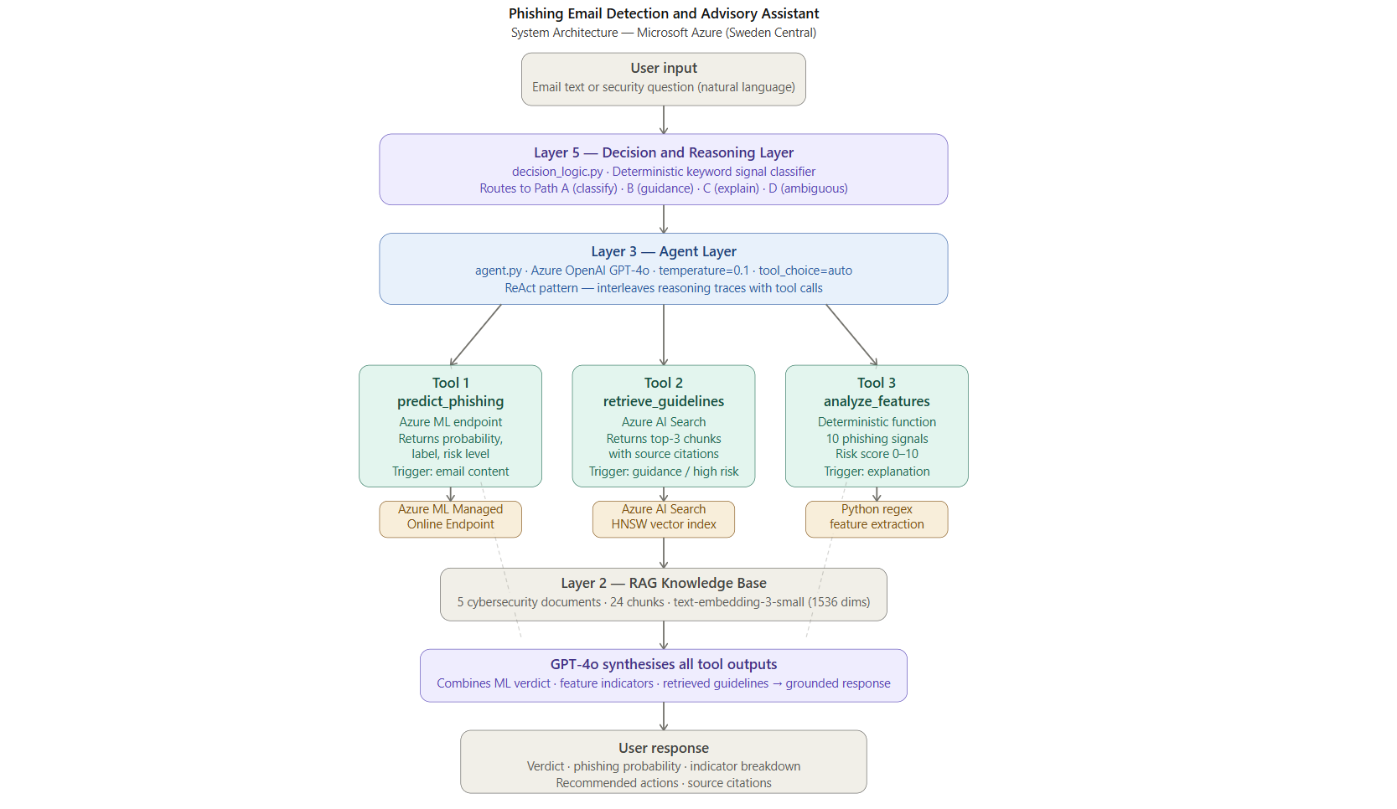
Figure 1- System Architecture showing five integrated layers on Microsoft Azure

Azure Services
Service | Purpose | Configuration
Azure AI Foundry | LLM + Agent hosting | fatema-hasan-it9204, Sweden Central
Azure OpenAI GPT-4o | Agent reasoning & synthesis | gpt-4o, Global Standard, 250K TPM
Azure OpenAI Embeddings | Text vectorization | text-embedding-3-small, 1536 dims
Azure AI Search | Vector store for RAG | fatema-hasan-search, Basic, Sweden Central
Azure ML Workspace | Model training & deployment | fatema-hasan-ml, Sweden Central
Azure ML Managed Endpoint | ML model serving | phishing-online-endpoint, DS3_v2
Table 1 - Azure Services Used in the System

Component Interaction Flow
- User enters a query (email text or security question).
- Using keyword signal analysis, the Decision and Reasoning Layer classifies the query into one of four routing paths (A, B, C, D).
- The AI agent gets the routing information and calls the relevant tools with GPT-4o.
- The Azure ML endpoint is called by the tools for classification, the Azure AI Search for RAG retrieval, and/or the deterministic feature extractor for indicator analysis.
- GPT-4o integrates the outputs of all tools into a coherent response that includes references and instructions.

Part A: Data and Knowledge Layer (RAG)

Document Selection
Five cybersecurity documents created in Markdown files make up the knowledge base. Because clean text provides better embeddings than PDF-extracted text, which frequently contains encoding artifacts, Markdown was selected over PDF (Shi et al., 2023).
Document | Primary Source | Content Focus
cisa_phishing_guidance.md | CISA (2024) | Attack types, indicators, recommended org actions
microsoft_email_security_best_practices.md | Microsoft (2024b) | SPF/DKIM/DMARC, detection, incident response
phishing_detection_techniques.md | Academic synthesis | ML features, linguistic indicators, risk thresholds
phishing_incident_response_procedures.md | NIST SP 800-61r3 (2024) | 4-phase response, roles, regulatory requirements
user_awareness_phishing_prevention.md | SANS Institute (2024) | Psychology of phishing, user recovery steps
Table 2 - RAG Document Knowledge Base

RAG Pipeline
The pipeline is defined on the file rag_pipeline.py.
- Document ingestion: Using regex to remove markdown symbols from .md files for clean embeddings.
- Chunking: Splitting the text into chunks of 300 words, each with a 50-word overlap, as suggested by Wang et al. (2025) for policy-based RAG.
- Embedding: Each chunk embedded with text-embedding-3-small (1536 dimensions) using Azure OpenAI deployment GlobalStandard.
- Indexing: Chunks indexed in Azure AI Search (phishing-knowledge-base) using HNSW vector search (Malkov & Yashunin, 2020).
- Retrieval: The query is embedded and a VectorizedQuery returns the top-k chunks most relevant to the query, and their sources are attributed.
The ingestion result is: 24 chunks uploaded, 5 documents. The range of retrieval quality scores is 0.63 - 0.77.
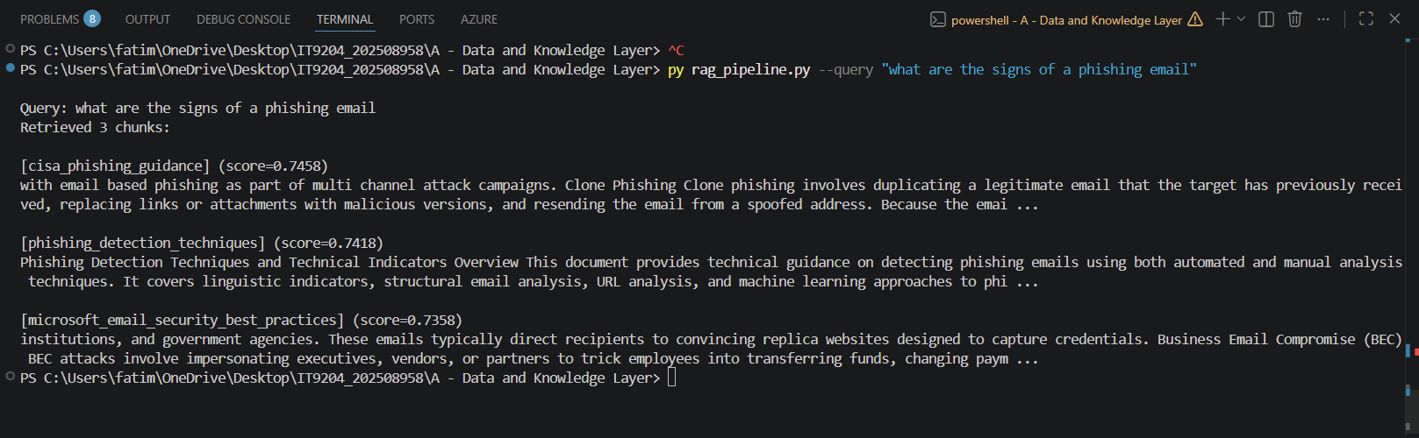
Figure 2 - RAG Retrieval Results

Part B: Machine Learning Component

Dataset
The dataset used was the Kaggle Phishing Email Detection (Subha Journal, 2023). To maintain class balance, stratified 80/20 sampling was used (Kotsiantis et al., 2006).
Property | Value
Source | Kaggle / Subha Journal (2023)
Total emails | 18,650
Phishing emails | 7,328 (39.3%)
Safe emails | 11,322 (60.7%)
Null rows removed | 16
Training set (80%) | 14,907
Test set (20%) | 3,727
Dataset link | https://www.kaggle.com/datasets/subhajournal/phishingemails
Table 3 - Phishing Email Dataset Statistics
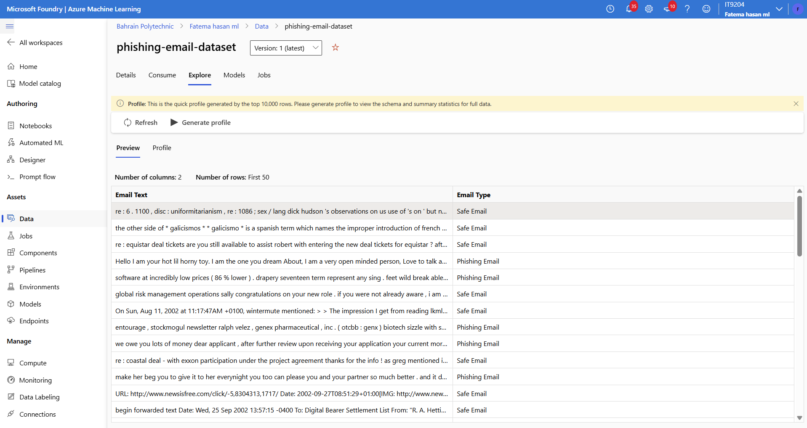
Figure 3 - Dataset Sample in Azure ML

Data Preparation
- Preprocessing: includes character normalization, truncation to 2,000 characters, URL tokenization (URL_PRESENT), email address tokenization (EMAIL_PRESENT), and lowercasing.
- TF-IDF features: 20,000 features, sublinear TF scaling, bigrams (ngram_range=(1,2)), and a minimum document frequency of two.
- Engineered phishing-signal features (10): has_url, url_count, has_urgent_words, has_financial_words, exclamation_count, dollar_count, text_length, caps_ratio, has_phone, and has_dear (Basit et al., 2021).
- Combined matrix: sparse format, 20,010 features (20,000 TF-IDF + 10 engineered).

Model Training: Manual Notebook
The Azure ML notebook (phishing_ml_training.ipynb) contains the Logistic Regression model that was trained with class weights. Wang and Zhang (2021) showed that Logistic Regression with TF-IDF is an interpretable and high-performing email classification method.
Metric | Safe | Phishing | Overall
Precision | 0.99 | 0.93 | 0.97
Recall | 0.95 | 0.98 | 0.96
F1-Score | 0.97 | 0.96 | 0.96
Accuracy |  |  | 96.40%
AUC-ROC |  |  | 99.36%
Table 4 - Manual Model Performance Results
The 98% phishing recall is really significant. According to Cormack (2008), security systems should prioritize reducing false negatives. Out of 1,462 test phishing emails, just 30 were missed.

Model Training: Azure AutoML
For six hours and twenty-five minutes, an Azure AutoML Classification experiment (fatema-hasan-automl-job) examined eight algorithm pipelines. Feurer et al. (2022) showed that by effectively scanning the hyperparameter space, AutoML can match or surpass manually trained models.
AutoML Setting | Value
Task | Classification (binary)
Primary metric | AUC Weighted
Models tried | 8 algorithm pipelines
Training duration | 6h 25m
Compute | fatema-hasan-compute (Standard_DS3_v2)
Best model | StandardScalerWrapper, LogisticRegression
Workspace | fatema-hasan-ml (Sweden Central)
Table 5 - AutoML Experiment Configuration
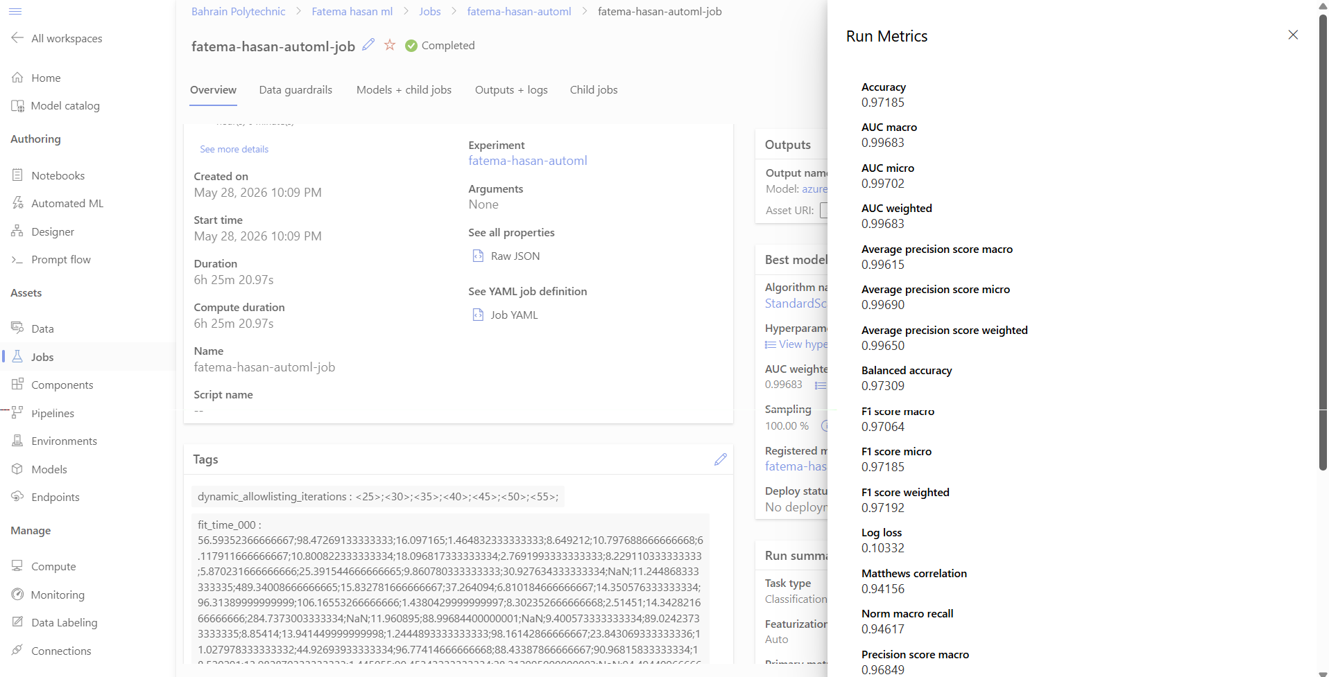
Figure 4 - AutoML Best Model Run Metrics showing AUC weighted of 0.99683

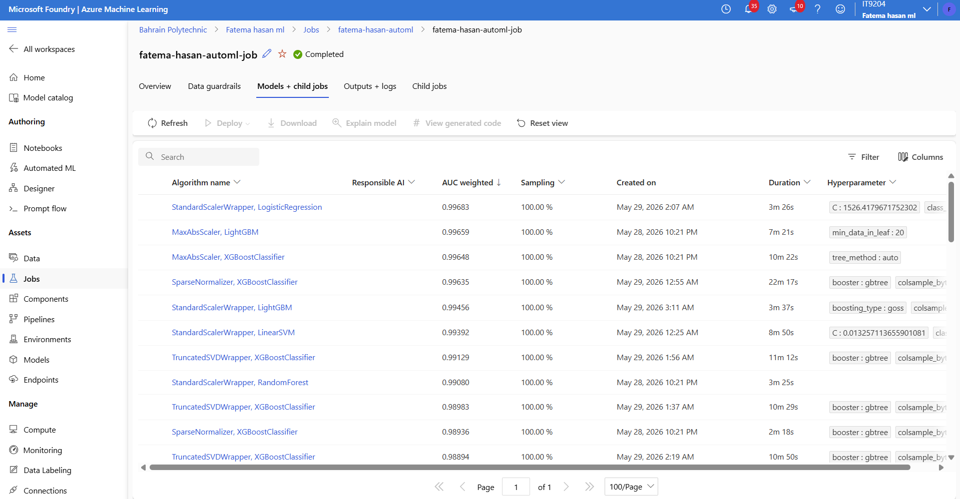
Figure 5 - AutoML Models + Child Jobs showing all algorithms ranked by AUC weighted score
Algorithm | AUC Weighted
StandardScalerWrapper, LogisticRegression (BEST) | 0.99683
MaxAbsScaler, LightGBM | 0.99659
MaxAbsScaler, XGBoostClassifier | 0.99648
SparseNormalizer, XGBoostClassifier | 0.99635
StandardScalerWrapper, LightGBM | 0.99456
StandardScalerWrapper, LinearSVM | 0.99392
TruncatedSVDWrapper, XGBoostClassifier | 0.99129
StandardScalerWrapper, RandomForest | 0.99080
Table 6 - AutoML Algorithm Comparison
Our manual model selection was validated by AutoML's independent selection of Logistic Regression as the optimal method. Through automatic hyperparameter optimization (C=1526.42), the AutoML best model (AUC: 0.99683) slightly outperformed the manual model (AUC: 0.9936). The AutoML best model was registered as fatema-hasan-phishing-automl-best-model:1.

Deployment
According to Microsoft's suggested design, the manual model was implemented as an Azure ML Managed Online Endpoint (2024c). To deploy, NumPy version conflict (ImportError: cannot import name ComplexWarning from numpy.core.numeric) must be fixed by pinning the precise package versions (phishing-env-v5).
Property | Value
Endpoint name | phishing-online-endpoint
Region | Sweden Central
Compute SKU | Standard_DS3_v2
Deployment type | ManagedOnlineDeployment (SDK v2)
Input | JSON: { email_text: string }
Output | prediction, label, phishing_probability, confidence
Table 7 - ML Endpoint Deployment Properties
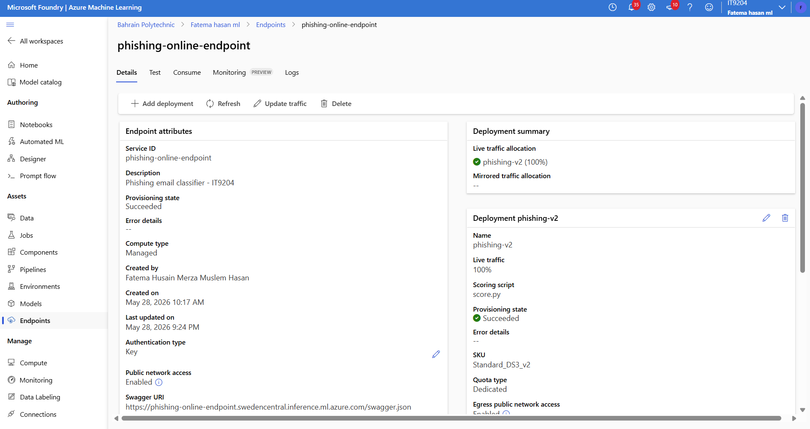
Figure 6 - Azure ML Managed Online Endpoint (phishing-online-endpoint)

Part C: Agent System

Agent Design
The ReAct pattern (Yao et al., 2023) is implemented by the agent (agent.py) using Azure OpenAI GPT-4o (temperature=0.1, tool_choice=auto), interspersing tool calls with reasoning traces. The three-tool design adheres to the Toolformer principle, which states that the LLM chooses which tools to use and how to combine results (Schick et al., 2023).

Tools
Tool | Purpose | Trigger
predict_phishing | Calls Azure ML endpoint; returns phishing_probability (0-1), label, risk_level (Low/Medium/High/Critical) | Email classification queries; probability ≥ 0.70 also triggers retrieve_guidelines
retrieve_guidelines | Vector search over Azure AI Search knowledge base; returns top-3 chunks with source citations | Policy/guidance questions; after high-risk ML prediction
analyze_email_features | Deterministic extraction of 10 phishing signal features; returns indicators and composite risk score (0-10) | Email analysis and explanation requests
Table 8 - Agent Tools
Risk level mapping: Low (< 0.40), Medium (0.40–0.69), High (0.70–0.84), Critical (≥ 0.85).

Multi-Step Reasoning Example
Query: URGENT! Your PayPal account is suspended. Verify NOW: http://paypal-secure-verify.xyz. Act within 24 hours! Dear Customer.’
- analyze_email_features: generic welcome, financial terms [PayPal, account], urgency phrases [urgent, verify, act immediately], and URL found. 6.5 out of 10 for feature risk.
- predict_phishing: risk_level=critical, label=Phishing Email, phishing_probability=0.8898.
- retrieve_guidelines triggered (probability ≥ 0.70): retrieves from microsoft_email_security_best_practices (0.7289), cisa_phishing_guidance (0.7316), and phishing_incident_response_procedures (0.7644).
- GPT-4o combines all outputs to produce a structured answer that includes a verdict, indications, proposed actions, and source citations.

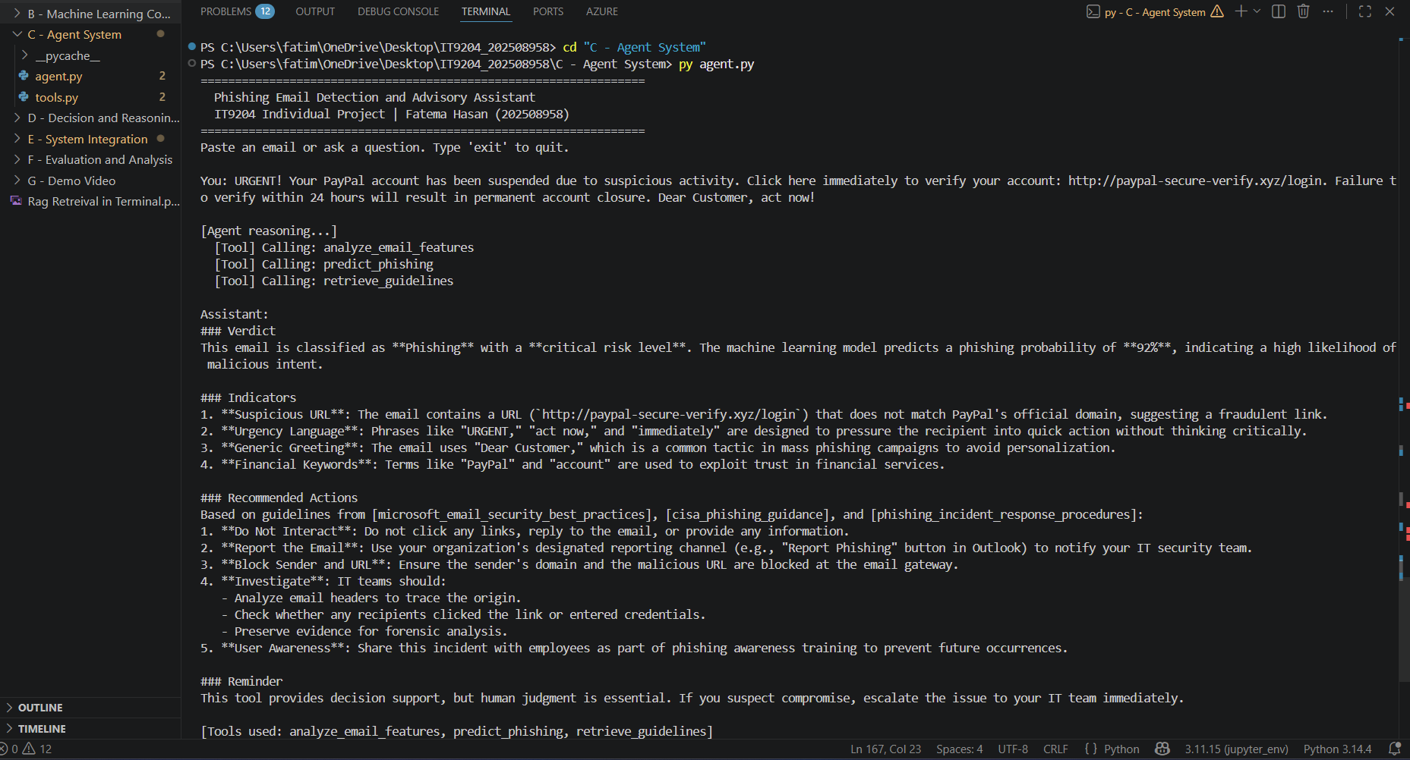
Figure 7 - Agent detecting a phishing email - all three tools called in sequence (Path A routing)
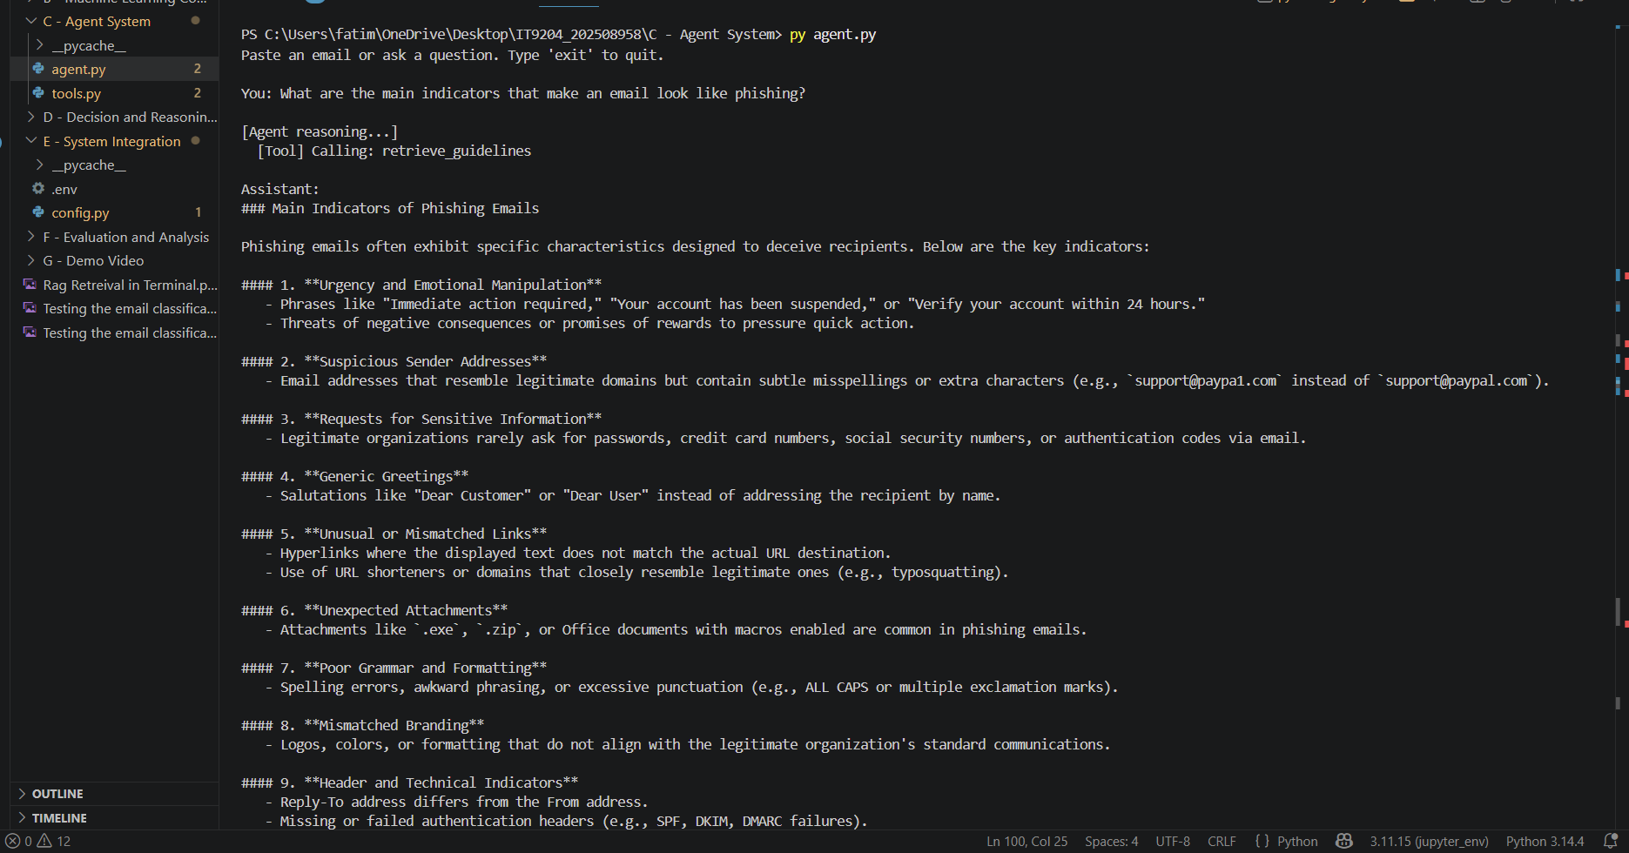
Figure 8 - Agent responding to a guidance query - only retrieve_guidelines called (Path B routing)

Part D: Decision and Reasoning Layer

Routing Strategy
The second layer is the decision layer, and the classifier that identifies a deterministic keyword signal (decision_logic. py). This hybrid method is in line with the work of Mei et al. OmniRouter framework in (2024) that showed it is possible to exceed the routing accuracy of using an LLM by directly adding intent classification.
- Path A (Classification): Classification signals ≥ 2.
Tools: analyze_email_features then predict_phishing then get_guidelines (if P ≥ 0.70).
- Paths B (Guidance): Guidance signals greater than or equal to 1
Tools: retrieve_guidelines only.
- Path C (Explanation): Explanation signals ≥ 2.
Tools: analyze_email_features + retrieve_guidelines.
- Path D (Ambiguous): Default fallback.
Tools: retrieve_guidelines.
Function should_retrieve_guidelines(ml_result): This acts as a risk gate. RAG is triggered when phishing_probability ≥ 0.70 so that no safe email incurs any unnecessary latency in retrieval of guidelines from database.

Decision Flow
The entire decision flow in the routing layer is shown in figure 9. Before query is passed on to an agent, a user query is received, and the classifier analyzes the keyword signals and selects the best combination of tools. The operation of the flow is as follows:
All queries are directed to the Query Classifier (classify_query()) which performs classification, guidance and explanation individually. The best signal takes. Path D is used as a default in situations where there is no clear dominant signal to use, and is a safe choice to keep the user from receiving a signal without ground.
A secondary risk gate is used within Path A to decide whether to call retrieve_guidelines after ML prediction. Only activated in case of a high or medium risk e-mail, so that the additional latency of a RAG call will not occur for low-risk cases. This design ensures response times are kept quick for safe emails and high-risk emails get complete policy-based guidance.
At the last synthesis stage, GPT-4o fuses all tool outputs into a single, structured response, aligning all four paths. The human operator then reviews the recommendation and finalizes the action (no autonomous system action).
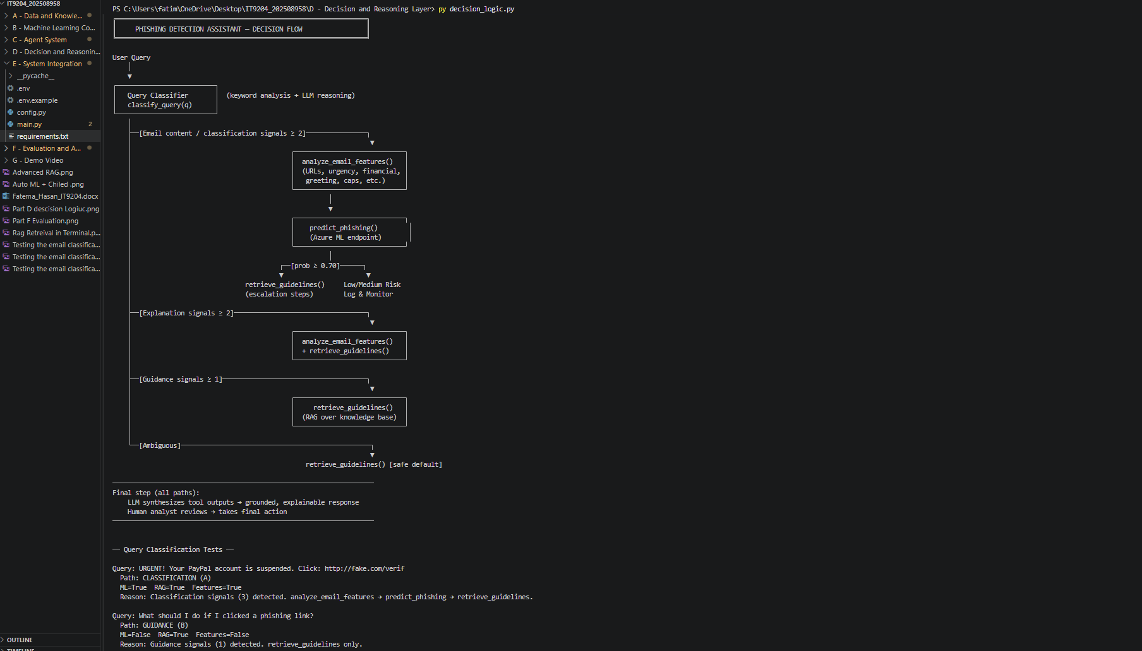
Figure 9 - Decision and Routing Layer: Query Classification and Tool Dispatch
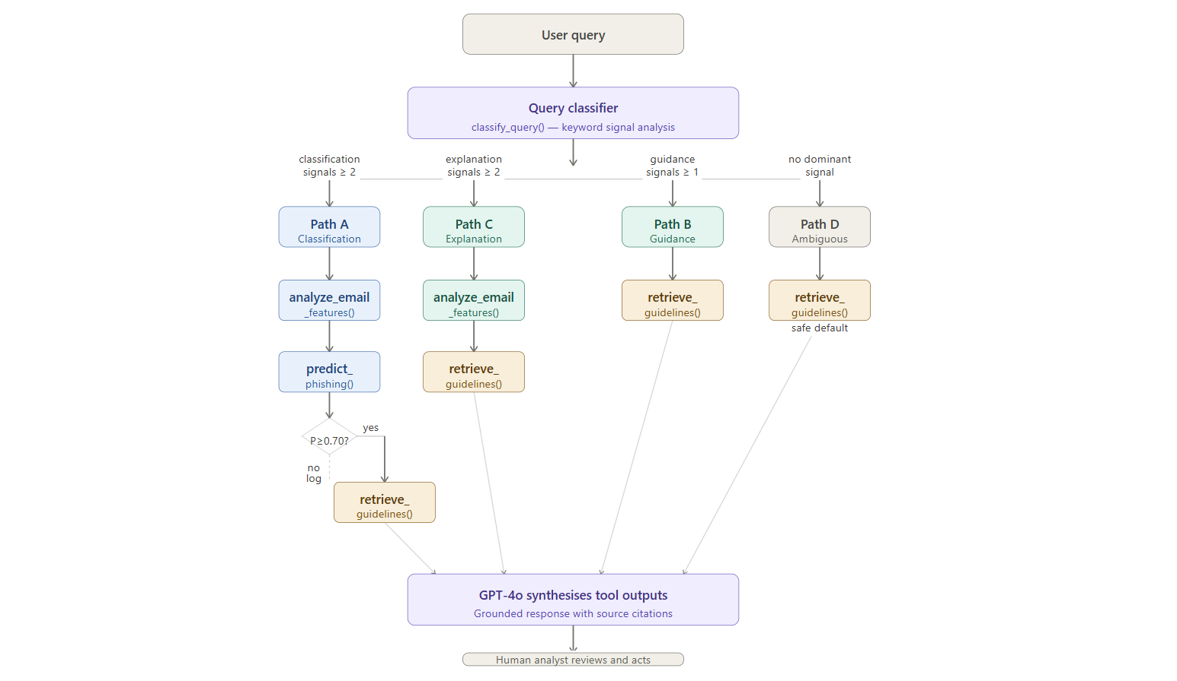
Figure 10 - Decision and Reasoning Layer - query routing flow across four paths

Part E: System Integration
In main.py, the integration is complete. The flow of integration is:
- User query arrives at the system entry point (main.py).
- decision_logic. classify_query() classifies the query and logs the routing choice.
- agent. answer_query() implements the agentic loop: GPT-4o keeps choosing tools through function calling, eventually producing an ultimate answer.
- Tools call the Azure ML endpoint, Azure AI Search and/or your deterministic feature extractor.
- GPT-4o concatenates every tool output into a response and includes citations to sources used wherever appropriate.
- The evaluation result (a JSON file) will be saved in F - Evaluation and Analysis with timestamped for auditing.
Through config.py loaded from. env variables, the configuration is shared throughout all of them. RAG settings: CHUNK_SIZE=300, CHUNK_OVERLAP=50, TOP_K=3. Thresholds: HIGH_RISK=0.70, MEDIUM_RISK=0.40.
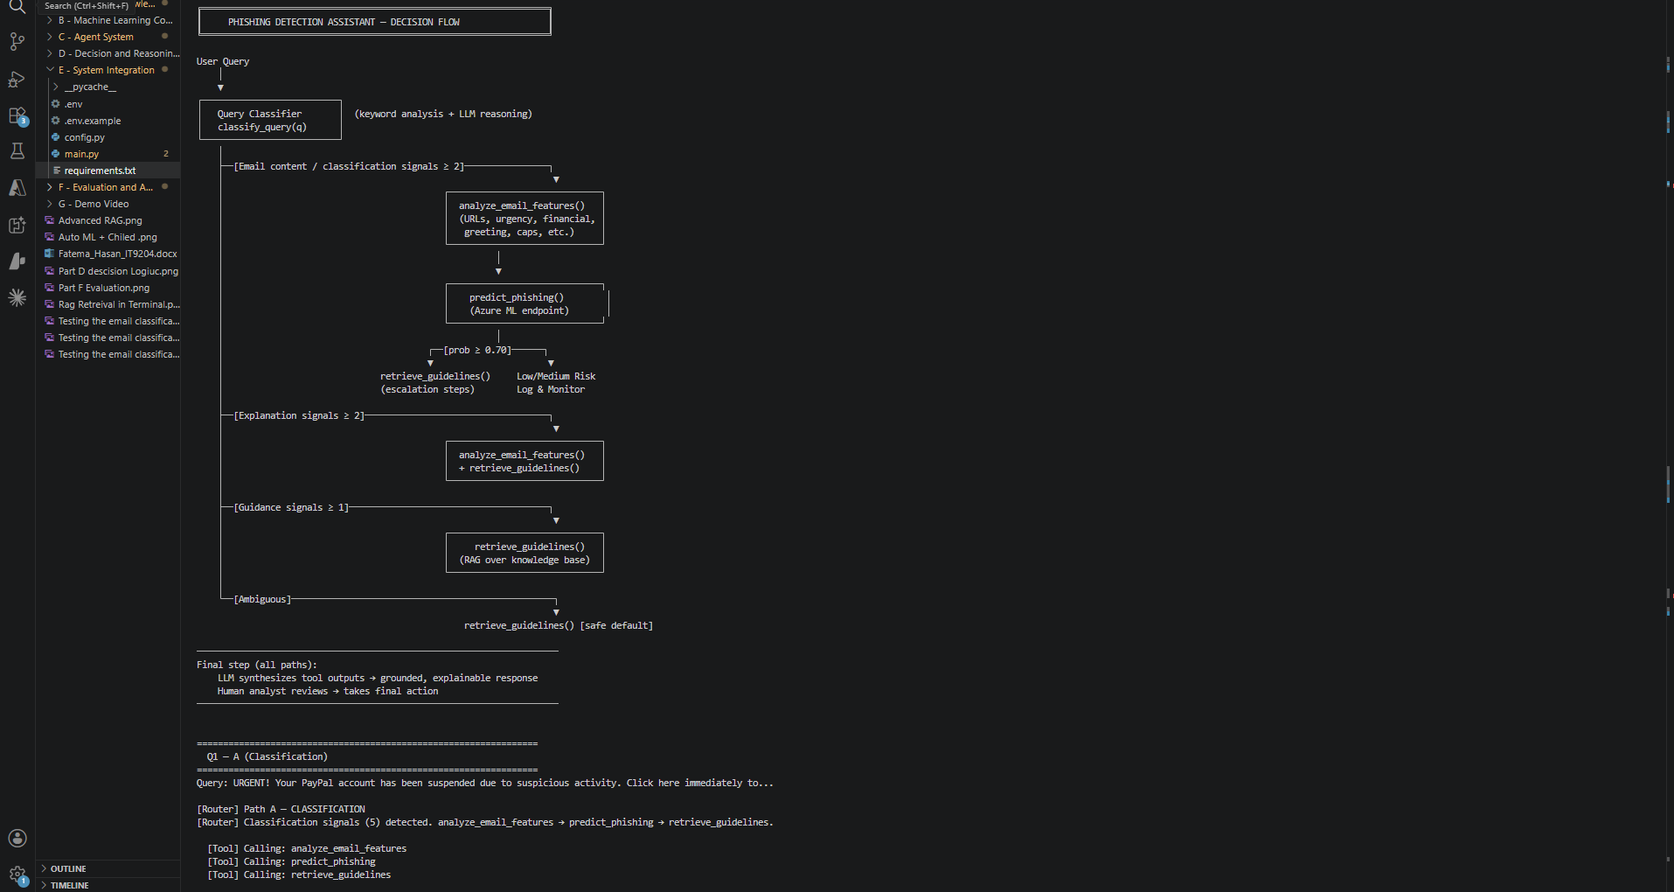
Figure 11 - System integration showing decision flow and routing of Q1 classification query
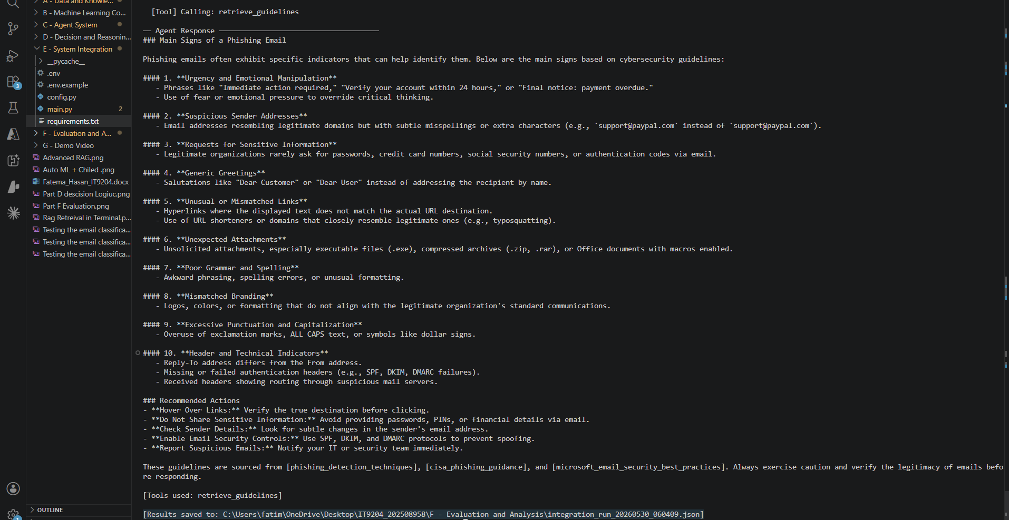
Figure 12 - System integration run showing agent response and results saved to JSON audit log

Part F: Evaluation and Analysis

Routing Evaluation Results
Ten test cases spanning every routing path were created and assessed using the Shen et al. (2023) technique for RAG-based systems.
Metric | Result
Overall routing accuracy | 100% (10/10)
Path A (Classification) | 6/6 correct
Path B (Guidance) | 2/2 correct
Path D (Ambiguous) | 2/2 correct
Table 9 - Routing Evaluation Results

System Evaluation Results
ID | Category | Expected | Actual | ML Score | Result
T01 | Obvious phishing | Phishing | Phishing | 0.7621 | Correct
T02 | Prize scam | Phishing | Phishing | 0.9585 | Correct
T03 | Credential harvest | Phishing | Phishing | 0.7279 | Correct
T04 | Business email | Safe | Safe | 0.0315 | Correct
T05 | Colleague email | Safe | Safe | 0.1771 | Correct
T06 | Newsletter (F1) | Safe | Phishing | 0.7708 | False positive
T07 | Incident response | Guidance | Guidance | N/A | Correct
T08 | Policy question | Guidance | Guidance | N/A | Correct
T09 | Borderline | Review | Phishing | 0.7611 | Flagged
T10 | Borderline | Review | Phishing | 0.9361 | Flagged
Table 10 - System Evaluation Test Cases

Metric | Value
Overall accuracy (judged cases) | 87.5% (7/8)
Phishing detection rate | 3/3 (100%)
Safe classification rate | 2/3 (66.7%)
Guidance routing accuracy | 2/2 (100%)
Avg. response time (direct tools) | 1.52 seconds
Avg. response time (agent + LLM) | 6–15 seconds
RAG retrieval score range | 0.63–0.77
Table 11 - System Performance Summary
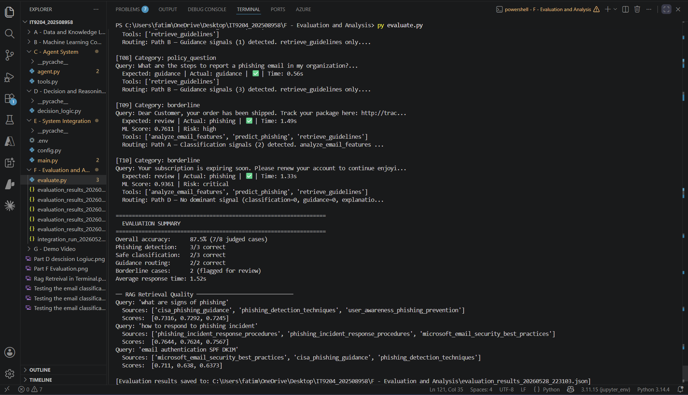
Figure 13 - Evaluation Results

Error Analysis and Failure Cases
F1 (Newsletter false positive): Query: ‘Welcome to the Monthly Newsletter… Unsubscribe anytime.’ Expected: Safe. Actual: Phishing (P=0.7708). Phishing language was included in the newsletter, in addition to the vocabulary. This 'vocabulary collision' was recognized as a limitation by Stringhini et al. (2024). In a security context, a false positive rather than a false negative is better (Cormack, 2008). Mitigation: put in place a human review queue in prediction range 0.60–0.80.

RAG Retrieval Quality
The pipeline retrieval was consistent in all of the test queries. The highest score was obtained on ‘how to respond to phishing incident’, with a score of 0.7644. The microsoft_email_security_best_practices was presented as first ranked (0.7289), which is correct for the ‘email authentication SPF DKIM DMARC’ keyword. The five documents were all recovered at least once, which indicates good document coverage of the corpus.

Limitations
- Text-only analysis: Does not support images, QR codes, or attachments.
- Language: Optimized for English emails only – accuracy on Arabic is unvalidated.
- Model needs to be retrained periodically because concept drift of phishing techniques (Gama et al., 2014).
- This content can be filtered out by a content filter, such as Azure OpenAI content management.
- Endpoint dependency: Needs an active Azure ML endpoint for the ML-based classification.

Proposed Improvements
- Add hybrid BM25 + vector search to Azure AI Search (already had an advanced_rag.py prototype).
- Make retrieve_guidelines required for all Path D queries in the system prompt.
- Incorporate sender domain reputation as a feature to minimize vocabulary-collision true false.
- Create a real-time analyst dashboard with Streamlit to submit interactive queries.

Responsible AI and Ethical Considerations
Microsoft's Responsible AI principles were followed during the evolution of the Phishing Email Detection and Advisory Assistant (Microsoft, 2024a), which have been defined as principles of fairness, reliability, privacy, inclusiveness, transparency, and accountability.
Principle | Implementation
Human Oversight | Human Analyst Responsible for All Final Action is stated in the system prompt. Each answer requires the inclusion of: This tool is for decision support but requires human judgment.
Transparency | Agent cites source documents for all policy statements. Details of the probability of and risk of features disclosed. The traces generated by tools stored in JSON.
Fairness | Only trained on emails in English might cause representation bias for non-English phishing (Mehrabi et al., 2022). Samples for GCC deployment, in Arabic language.
Data Privacy | This is done through Microsoft enterprise data protection with the help of Azure OpenAI and Azure ML. Organizations are responsible for making sure Bahrain PDPL (2019) compliant. Resources in the central part of Sweden.
Reliability | For Logistic Regression the accuracy is 96.40% and the AUC-ROC is 99.36%. AutoML validated: 0.99683 AUC. Class weights are balanced, so there is no class bias against minorities.
No Hallucinated Policy | System prompt: 'Don't give false security suggestions. Any recommendations must be based on documents retrieved.
Auditability | All agents executed log tools, arguments and results to JSON. Deterministic routing allows audit to be done without LLM.
Limitations | Prototype only. Needs to be re-trained with data and Arabic language samples from the organization before production.
Table 12 - Responsible AI Implementation
This strategy is in accordance with the Human-AI interaction recommendations of Amershi et al. (2019), the explainability framework of Arrieta et al. (2020), and Microsoft's (2024a) Responsible AI principles.

Part I: Extra Challenging Work
We then added an advanced RAG pipeline (advanced_rag.py), which is the same pipeline as from the survey of Gao et al. (2024) but with three improvements over basic vector search:
- BM25 keyword retrieval: Implements the BM25Okapi (Robertson & Zaragoza, 2009) technique for sparse keyword matching, to retrieve exact technical term matches.
- Reciprocal Rank Fusion (RRF): Fusion of BM25 and vector search ranking with k=60 (Cormack et al., 2009).
- CrossEncoder reranking: CrossEncoder reranking candidates with more accurate relevance judgements than cosine similarity (Reimers & Gurevych, 2019).
Find out about email authentication SPF DKIM DMARC with one of the most powerful comparison tools.
- Basic vector search: microsoft_email_security_best_practices scored 0.7289, which was the top score.
- Advanced reranking: - cisa_phishing_guidance' reranked to first (CrossEncoder score=5.9081) Correctly displays more specific SPF/DKIM guidance.
The result is similar to that of Nogueira and Cho (2020), who demonstrated that CrossEncoder reranking always achieves better performance than bi-encoder similarity on information retrieval benchmarks.

Conclusion
This project has achieved the complete integration of a cloud-based AI system, encompassing RAG, ML, and an LLM agent for phishing email detection, with a multi-step reasoning approach. The system achieved:
- Manual classifier with 96.40% accuracy, 99.36% AUC-ROC; AutoML: 0.99683 AUC, Logistic Regression is optimal.
- 100% accuracy in route decisions in 10 test-cases at the deterministic decision logic layer.
- Overall system accuracy of 87.5% (100% phishing detection rate) in tool evaluation.
- Full integration end-to-end (Azure AI Foundry: GPT-4o, Azure AI Search: 5 documents, 24 chunks, Azure ML: managed endpoint).
- Advanced RAG using Hybrid BM25 + vector search and CrossEncoder reranking, which proved to be measurable in terms of retrieval quality.
- All responsible AI principles are put in place (human oversight, transparency, fairness, privacy, reliability and auditability).
Emphasis in all design activities is given to system design and integration, not just model performance, consistent with course goals. The results are also concordant with the results of Wang et al. (2024) which shows that multi-component LLM agent systems outperform single-model approaches on complex reasoning tasks.

Future Work
There are several directions that are suggested for the future development of the system:
Multi-Language support: Only English language emails are currently supported. The inclusion of Arabic language phishing samples would greatly enhance applicability in Bahrain and the wider GCC region where the number of phishing campaigns targeting Arabic speakers is on the rise.
Adaptive retraining pipeline: Concept drift over time reduces the accuracy of models when phishing methods are constantly changing (Gama et al., 2014). An automated pipeline that ingests new phishing samples on a periodic schedule could ensure that the classification would not need to be manual.
Email header analysis: Only body text of emails is analysed. Adding email header information such as SPF, DKIM and DMARC Header: Results, Reply-To, domain age, etc. mismatches, would greatly lessen false positives from vocabulary collisions between genuine and spam commercial emails and spam vocabulary.
Real-time analyst dashboard: The Streamlit-based dashboard could enable security analysts to submit queries, visually explore phishing probability distributions within email batches and review flagged emails via a structured workflow, moving beyond a command-line prototype to a deployable security operations tool.
Multi-agent architecture: A sub-agent design of these specialists would allow for the separation of classification, explanation, and guidance sub-agents, which may lead to better response quality and the ability to execute the tools parallelly, thus reducing the response time.

References
- Amershi, S., Weld, D., Vorvoreanu, M., Fourney, A., Nushi, B., Collisson, P., Suh, J., Iqbal, S., Bennett, P. N., Inkpen, K., Teevan, J., Kikin-Gil, R., & Horvitz, E. (2019). Software engineering for machine learning: A case study. Proceedings of the 41st International Conference on Software Engineering, 291–300.
- Arrieta, A. B., Díaz-Rodríguez, N., Del Ser, J., Bennetot, A., Tabik, S., Barbado, A., García, S., Gil-López, S., Molina, D., Benjamins, R., Chatila, R., & Herrera, F. (2020). Explainable artificial intelligence (XAI): Concepts, taxonomies, opportunities and challenges toward responsible AI. Information Fusion, 58, 82–115.
- Basit, A., Zafar, M., Liu, X., Javed, A. R., Jalil, Z., & Kifayat, K. (2021). A comprehensive survey of AI-enabled phishing attacks detection techniques. Telecommunication Systems, 76(1), 139–154.
- CISA. (2024). Phishing guidance: Stopping the attack cycle at phase one. Cybersecurity and Infrastructure Security Agency. https://www.cisa.gov
- Cormack, G. V. (2008). Email spam filtering: A systematic review. Foundations and Trends in Information Retrieval, 1(4), 335–455.
- Cormack, G. V., Clarke, C. L. A., & Buettcher, S. (2009). Reciprocal rank fusion outperforms condorcet and individual rank learning methods. Proceedings of the 32nd International ACM SIGIR Conference, 758–759.
- Fette, I., Sadeh, N., & Tomasic, A. (2007). Learning to detect phishing emails. Proceedings of the 16th International Conference on World Wide Web (WWW), 649–656.
- Feurer, M., Eggensperger, K., Falkner, S., Lindauer, M., & Hutter, F. (2022). Auto-Sklearn 2.0: Hands-free AutoML via meta-learning. Journal of Machine Learning Research, 23(261), 1–61.
- Gama, J., Žliobaite, I., Bifet, A., Pechenizkiy, M., & Bouchachia, A. (2014). A survey on concept drift adaptation. ACM Computing Surveys, 46(4), 1–37.
- Gao, Y., Xiong, Y., Gao, X., Jia, K., Pan, J., Bi, Y., Dai, Y., Sun, J., Wang, M., & Wang, H. (2024). Retrieval-augmented generation for large language models: A survey. arXiv preprint arXiv:2312.10997.
- Kotsiantis, S. B., Kanellopoulos, D., & Pintelas, P. E. (2006). Data preprocessing for supervised learning. International Journal of Computer Science, 1(2), 111–117.
- Lewis, P., Perez, E., Piktus, A., Petroni, F., Karpukhin, V., Goyal, N., Küttler, H., Lewis, M., Yih, W., Rocktäschel, T., Riedel, S., & Kiela, D. (2020). Retrieval-augmented generation for knowledge-intensive NLP tasks. Advances in Neural Information Processing Systems, 33, 9459–9474.
- Malkov, Y. A., & Yashunin, D. A. (2020). Efficient and robust approximate nearest neighbor search using hierarchical navigable small world graphs. IEEE Transactions on Pattern Analysis and Machine Intelligence, 42(4), 824–836.
- Mehrabi, N., Morstatter, F., Saxena, N., Lerman, K., & Galstyan, A. (2022). A survey on bias and fairness in machine learning. ACM Computing Surveys, 54(6), 1–35.
- Mei, K., Xu, W., Guo, M., Lin, S., & Zhang, Y. (2024). OmniRouter: Budget and performance controllable multi-LLM routing. arXiv preprint arXiv:2407.15953.
- Microsoft. (2024a). Responsible AI principles and approach. Microsoft Corporation. https://www.microsoft.com/en-us/ai/responsible-ai
- Microsoft. (2024b). Azure AI Search documentation. Microsoft Corporation. https://learn.microsoft.com/en-us/azure/search/
- Microsoft. (2024c). Azure Machine Learning managed online endpoints documentation. https://learn.microsoft.com/en-us/azure/machine-learning/
- NIST. (2024). Computer security incident handling guide (SP 800-61r3). National Institute of Standards and Technology. https://doi.org/10.6028/NIST.SP.800-61r3
- Nogueira, R., & Cho, K. (2020). Passage re-ranking with BERT. arXiv preprint arXiv:1901.04085.
- Reimers, N., & Gurevych, I. (2019). Sentence-BERT: Sentence embeddings using siamese BERT-networks. Proceedings of the 2019 Conference on Empirical Methods in Natural Language Processing, 3982–3992.
- Robertson, S., & Zaragoza, H. (2009). The probabilistic relevance framework: BM25 and beyond. Foundations and Trends in Information Retrieval, 3(4), 333–389.
- SANS Institute. (2024). Security awareness planning kit. SANS Institute. https://www.sans.org/security-awareness-training/
- Schick, T., Dwivedi-Yu, J., Dessì, R., Raileanu, R., Lomeli, M., Zettlemoyer, L., Cancedda, N., & Scialom, T. (2023). Toolformer: Language models can teach themselves to use tools. Advances in Neural Information Processing Systems, 36.
- Shen, Z., Patil, S. G., & Annavajhala, M. K. (2023). Large language model guided evaluation of retrieval-augmented generation systems. arXiv preprint arXiv:2310.01558.
- Shi, W., Min, S., Yasunaga, M., Seo, M., James, R., Lewis, M., Zettlemoyer, L., & Yih, W. (2023). REPLUG: Retrieval-augmented black-box language models. arXiv preprint arXiv:2301.12652.
- Stringhini, G., Wang, G., Egele, M., Kruegel, C., Vigna, G., Zheng, H., & Zhao, B. Y. (2024). Follow the green: Growth and dynamics in spam and phishing. Proceedings of IEEE Symposium on Security and Privacy.
- Subha Journal. (2023). Phishing email detection dataset. Kaggle. https://www.kaggle.com/datasets/subhajournal/phishingemails
- Verizon. (2025). Data breach investigations report 2025. Verizon Business. https://www.verizon.com/business/resources/reports/dbir/
- Wang, L., Ma, C., Feng, X., Zhang, Z., Yang, H., Zhang, J., Chen, Z., Tang, J., Chen, X., Lin, Y., Zhao, W. X., Wei, Z., & Wen, J. (2024). A survey on large language model based autonomous agents. Frontiers of Computer Science, 18(6).
- Wang, X., Chi, J., Tai, Z., & others. (2025). FinSage: A multi-aspect RAG system for financial filings question answering. arXiv preprint arXiv:2504.14493.
- Wang, Y., & Zhang, Y. (2021). Spam and phishing detection using deep learning: A comprehensive review. IEEE Access, 9, 81261–81278.
- Yao, S., Zhao, J., Yu, D., Du, N., Shafran, I., Narasimhan, K., & Cao, Y. (2023). ReAct: Synergizing reasoning and acting in language models. Proceedings of the 11th International Conference on Learning Representations (ICLR).

AI Disclosure
This project has been done with the support from AI tools and following Bahrain Polytechnic Academic integrity guidelines. The following tool was used:
For code generation, debugging, system design guidance, referencing in APA style and summarizing research papers Claude (Anthropic) helped with assistance throughout the project. All code that was created for the student was reviewed, tested and validated against actual Azure deployments. Student configured, deployed and tested all Azure services. This report contains all the evaluation results as actual output from the deployed system on the student's Azure subscription (IT9204).
The system design, system architecture and architectural decisions, technologies used, evaluation methodology, and the analysis of results are the student's own work. The code provided, policy, and configuration documents were written and tested by the student with AI assistance.

Project Resources
Resource | Link
Dataset | https://www.kaggle.com/datasets/subhajournal/phishingemails
Demo Video | https://youtu.be/FgLfeEq4M-k
Source Code | https://github.com/Fatimaxx24/202508958-IT9204-Emerging-Technologies-in-AI
Table 13 - Project Resources

